UNIVERSITY CAMPUS SECURITY SIMULATION
BCS303 / NET220 – Security Principles & Practices
Final Project Report
Group Members:
Mohammad Abdullah Marwan Mire Ali Yousuf
20230003944 20230003808 20240004471
1. Problem Statement
Most universities today have electronic systems to run their records, control access to buildings and services, manage communications and administer the academic process, and these systems are common targets of opportunity for attack, potentially granting access to the internal network. Weak authentication affects a system's confidentiality, integrity, and availability if unaddressed. Insecure configurations affect a system's confidentiality, integrity, and availability if unaddressed. SQL injection affects a system's confidentiality, integrity, and availability if unaddressed. Phishing affects a system's confidentiality, integrity, and availability if unaddressed. Network-based attacks affect a system's confidentiality, integrity, and availability if unaddressed.
One approach is to realistically reproduce the threats in a Kali Linux environment and deploy countermeasures against them in that environment. Learning can then focus on the ways vulnerabilities are introduced, the ways they can be exploited, and the ways cryptography, secure coding, access control, and monitoring improve system security. In doing a simulation that participants can take part in, the project allows participants to gain an understanding of cybersecurity principles by applying them.
2. Objectives
The goal of this project is to deploy a realistic small security model inside a Kali Linux virtual machine (VM) and show how all the security layers work together. This project will show security information scanning, data encryption and hashing, insecure code patching, database role-based access control, and network analysis using Nmap, firewall rules, and Wireshark. The project seeks to use these exercises to improve the knowledge of how to secure systems against threats.
3. Methodology
The entire work was done within a Kali Linux virtual machine and had a different security aspect related to each stage. The first stage was a basic security policy which implemented Nmap to analyze the system for open ports and vulnerabilities. Stage two was to use AES-GCM and SHA-256 cryptography to secure a CSV file with student records. In stage three the assignment was to run a vulnerable login script and then exploit it using SQL-like characters before replacing the script with a fixed version that removed the characters. The fourth stage concerned hardening a simulated database implemented using a nested dictionary then implementing role-based access controls to ensure the full database was secure from everyone except administrators. The final task involved scanning networks, modifying firewall rules, capturing then analyzing network traffic through Wireshark and detecting possible signs of malicious activity on the networks. Screenshots were taken through each of these tasks.
4. Implementation and Results
4.1 Phase 1 – Security Policies & Threat Analysis
Security Policy:
“A short sample security policy for a fictitious university computing system is codified in the standard. It outlines a mandatory strong password policy and forbids the sharing of passwords among users of the computing system. The policy requires limits on access to databases, use of only authorized devices to connect to the internal network, encryption of sensitive information stored on local devices, and logging of suspicious login attempts. To avoid opening emails which require entering credentials, or redirecting to unknown links, any emails must be verified first. The main aim of this policy is the system's confidentiality, integrity, and availability.”
After writing the policy, Nmap was run on the local VM for determination of any open ports and the services that were running. The scan results showed PORT 22/tcp available for exploitation.
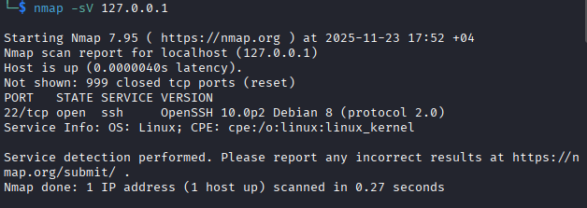
Risk Table:
Vulnerability Name Open Port Version
TCP Port 22 OpenSSH 10.0p2 Debian 8
The attacks revealed in the scan results can be interpreted in the context of the CIA triad. For example, brute-force attacks may violate confidentiality by guessing a set of credentials. Integrity violations are SQL injection, which allows the attacker to insert, read, or change entries in the database, and confidentiality violations are phishing emails that convince users to reveal their passwords. Port scanning, being an indication that denial of service or other availability attacks are possible, provides an opportunity for the architect to design countermeasures.
4.2 Phase 2 – Cryptography Simulation
The ten user accounts (username/password and email) generated in a CSV file were used as the dataset in the cryptography phase.
The AES-GCM script was run on this file, which used PBKDF2 to derive a cryptographic key from the entered password. Then, the passwords were encrypted with AES-GCM (a symmetric key encryption algorithm that guarantees confidentiality and integrity of data and uses an authentication tag), and saved in a new provide-go-for-everyone/students_encrypted.csv file.
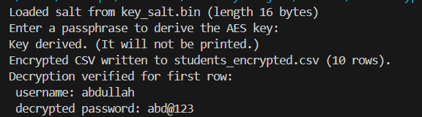
Original Student CSV File:
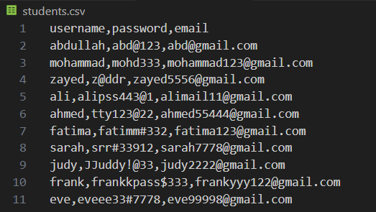
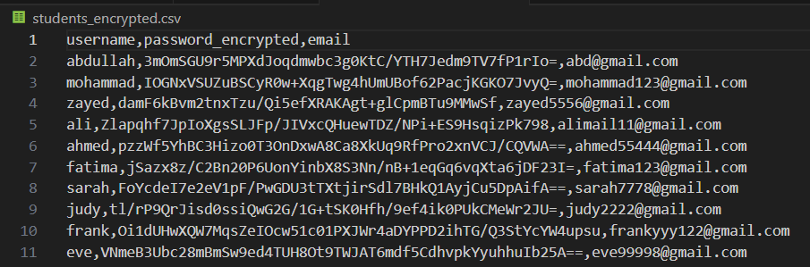
Encrypted Student CSV File:

The script would then decrypt the first entry to confirm encryption succeeded and create a SHA-256 hash of the chosen student's password. The script would finish by checking the SHA-256 hash corresponding to the user's inputted password.
Verifying Hash with Correct Password:
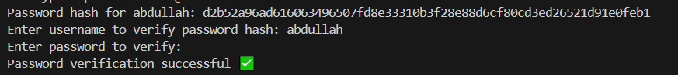
Verifying Hash with Incorrect Password:
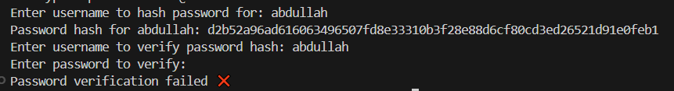
It was during this period that it was recognized that encryption prevented attackers from reading users' passwords if they gained access to the files, and hashing became widely known.

4.3 Phase 3 – Program Threats & User-Side Defences
To show this attack, a vulnerable Python login script which builds a query via string concatenation and then evaluates that string as a query using Python's built-in eval() function was used. If this script is provided with the parameter admin' OR '1'='1, the account of the user who supplied this parameter is erroneously authenticated, showing the vulnerability to SQL injection.
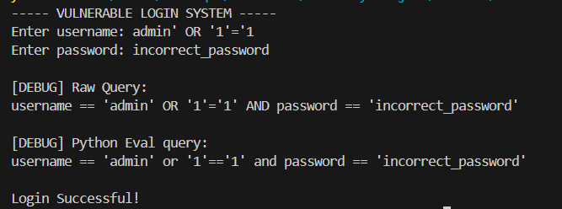

For reduction of this vulnerability, the script was moved out of the web server's document root. It also validated input for quotes, semicolons and double hyphens by rejecting them as soon as the user hit Enter, and the script warned the user. If the user reused their attempt, the script blocked it.
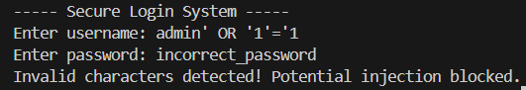
Someone sent a phishing email to students that seemed to send from the university IT department. The email requested students input their login details into a link to a fake website. The email had various hallmarks of a phishing attempt, like a non-official URL, urgent tone, and generic greeting.
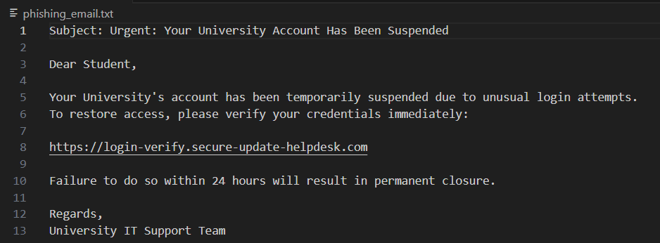It thus highlighted the need for secure coding practices and user education about these common attacks.

4.4 Phase 4 – Database Security & Access Control
In the next step we simulated a database using a nested dictionary. This structure stored usernames, passwords, e-mail addresses, and user roles (admin and student), allowing the system to perform access control and demonstrate how SQL injection attempts could affect authentication.
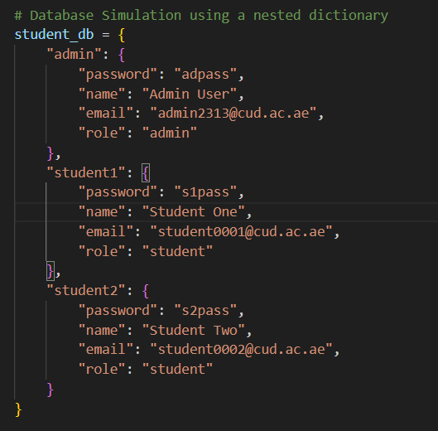
This was then expanded with role-based access control so that the administrators view the whole database and the regular students view only their own data to keep the personal data of users private from other users.
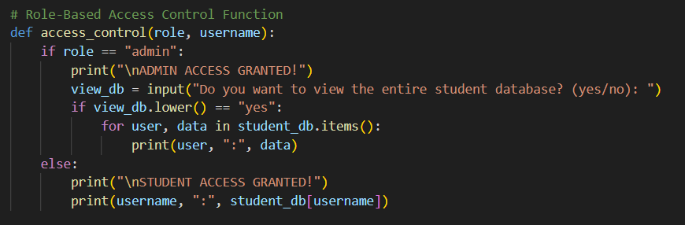
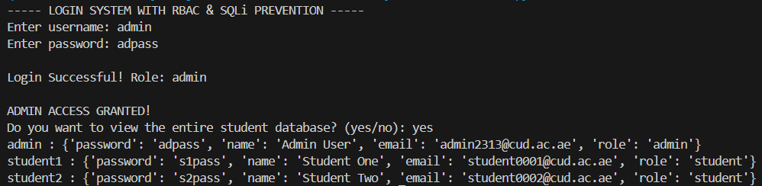

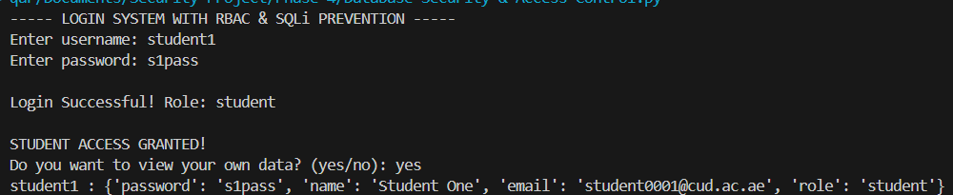
In the vulnerable version of the previous query, inputting a condition like ' OR 1=1 -- returns multiple results; the input was not checked properly, and this allows an SQL injection attack.
This was avoided when rewriting the login function to use prepared statements (in which special characters are treated as literals, and cannot alter the meaning of a SQL command), as the same input no longer produced unauthorized records.
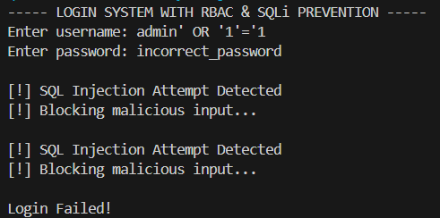
This period demonstrated that role-based access controls and good SQL writing could keep the data valid.

4.5 Phase 5 – Network Security & Monitoring
The final stage was locking down the network itself, followed by another Nmap scan to identify open services and check for any remaining open ports that weren't required.
Attackers could set up a fake Wi-Fi access point on a school campus. Students would connect to it instead of the school's network. This is similar to spoofing an unauthorized Wi-Fi network. The attackers could then man-in-the-middle network traffic, acquire passwords and other credentials, and steal information. This highlights the need of secure wireless policies and user awareness.
A simple firewall rule was added using UFW to block all access to port 23, the default port for Telnet connections which is not considered secure, following which access to the server was blocked.
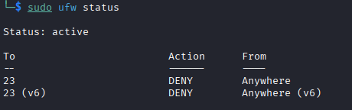
The network traffic was then captured with Wireshark. It was demonstrated that it is very easy to capture unencrypted plaintext data besides sending simple packets like
ARP and ICMP. One potential problem was unencrypted packets that would therefore expose information in human-readable form.
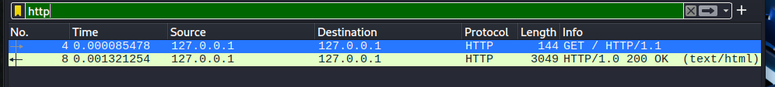
Finally, the CIA triad was analyzed. Someone protected confidentiality by encrypting data and using secure channels. Integrity was ensured SQL injection attacks were avoided and RBAC was used. To ensure availability, firewall rules and network monitoring were employed.
5. Discussion
Working through each phase of this project made it clear that, at different layers, different types of vulnerabilities would emerge. These vulnerabilities might manifest at the level of code, in policy, at the level of services and on the network. With each defensive technique, additional security was gained, but no one attack surface would be sufficient. While encryption, role-based access controls (RBAC), firewall rules, user education, secure code habits, and monitoring can create an impressive wall of protection, the work on this project made it apparent that any one of these areas could make a seemingly small mistake or omission that would result in catastrophic consequences.
6. Conclusion
The University Campus Security Simulation was a computer security simulation that demonstrated how to analyze and protect computer systems in a university campus environment. It covered encryption, hashing, program security, database access, and network monitoring. Every phase taught something about how an attacker would exploit the vulnerability and how to protect the system. At a high level, this project helped me learn about cybersecurity and get practice with designing a more secure system.

Source Code Files (Google Drive):
https://drive.google.com/drive/folders/1ILh6xGGaC03LzdkzvV0s5UhJrXCWDxMm?usp=sharing

